Internet Of Things Year 2 Assignment

## Embedded Application Development

Name: Luke Halley

Course: Internet Of Things

Student Number: 20071820

Date: 29th November 2016

Submission Due Date: 2nd December 2016

## **Design (Using circuits.io):**

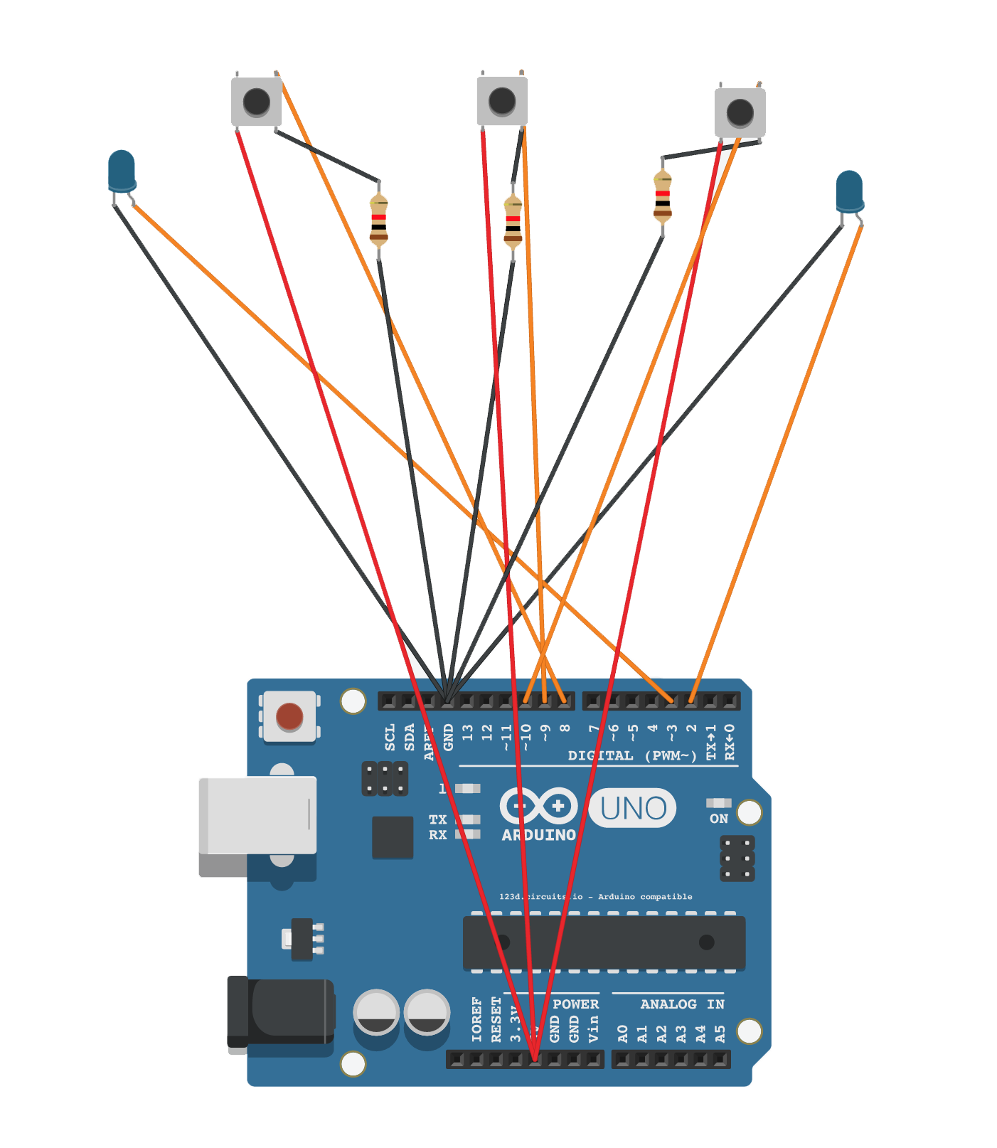

Components Used:

* Arduino Uno
* Three Buttons
* Two LEDS
* Connecting Wires
* Three Resistors

## **State Chart:**

statechart.png

**C Code:**

int TIME_INTERVAL = 250; //0.5 Seconds

int HAZARD_IND = 0, LEFT_IND = 0, RIGHT_IND = 0, RIGHT_LED = 2, LEFT_LED = 3;

void setup()

{

pinMode(2, OUTPUT); //RIGHT LED

pinMode(3, OUTPUT); //LEFT LED

pinMode(8, INPUT); //LEFT INDICATOR

pinMode(9, INPUT); //HAZARD

pinMode(10, INPUT); //RIGHT INDICATOR

}

void loop()

{

HAZARD_IND = digitalRead(9);

LEFT_IND = digitalRead(8);

RIGHT_IND = digitalRead(10);

//Hazard Code

if (digitalRead(HAZARD_IND) == 0) {

digitalWrite(LEFT_LED, HIGH);

digitalWrite(RIGHT_LED, HIGH); // turn on both the LEDs

delay(TIME_INTERVAL); // wait one a second

digitalWrite(LEFT_LED, LOW);

digitalWrite(RIGHT_LED, LOW); // turn off both the LEDs

delay(TIME_INTERVAL); // wait for a second

}

//Left Indicator Code

if (digitalRead(LEFT_IND) == 0 && digitalRead(HAZARD_IND) != 0) {

digitalWrite(LEFT_LED, HIGH); // turn the LED on (HIGH is the voltage level)

delay(TIME_INTERVAL); // wait for a second

digitalWrite(LEFT_LED, LOW); // turn the LED off by making the voltage LOW

delay(TIME_INTERVAL); // wait for a second

}

//Right Indicator Code

if (digitalRead(RIGHT_IND) == 0 && digitalRead(HAZARD_IND) != 0) {

digitalWrite(RIGHT_LED, HIGH); // turn the LED on (HIGH is the voltage level)

delay(TIME_INTERVAL); // wait for a second

digitalWrite(RIGHT_LED, LOW); // turn the LED off by making the voltage LOW

delay(TIME_INTERVAL); // wait for a second

}

}